**AWS Challenge**

Launch one **EC2 instance** using **Amazon Linux 2**

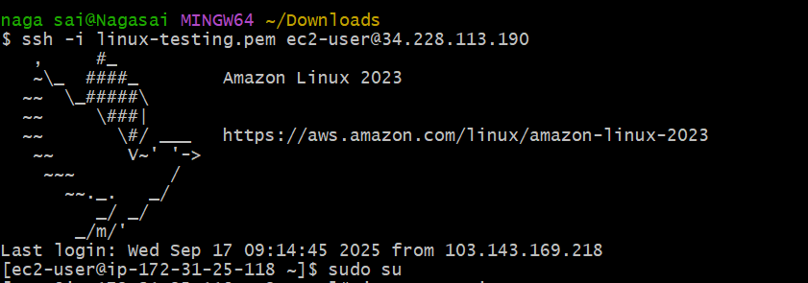

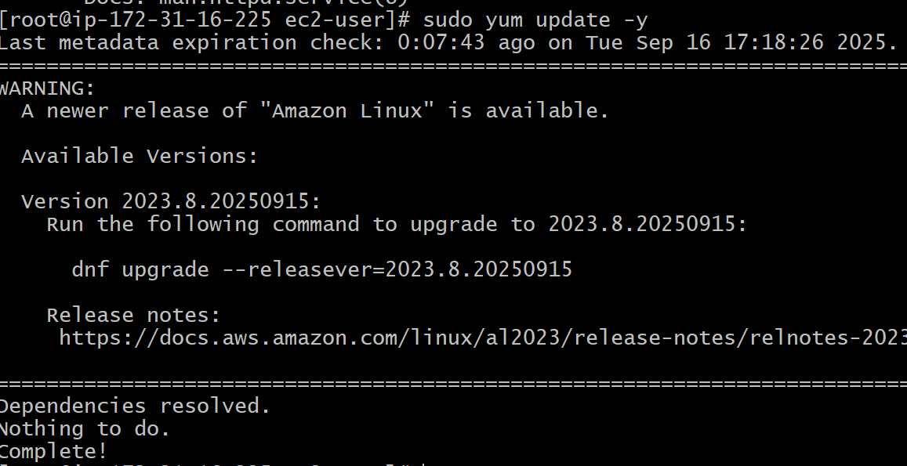

1.Install docker

Yum install -y docker

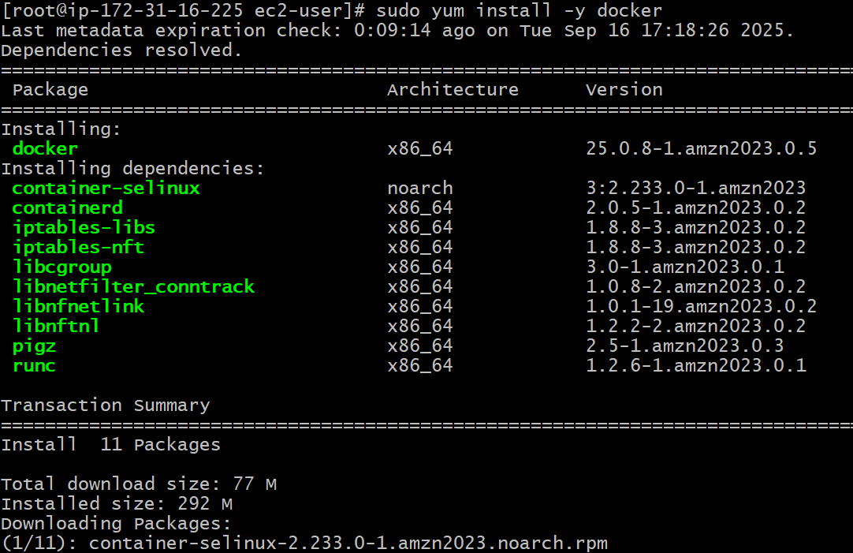

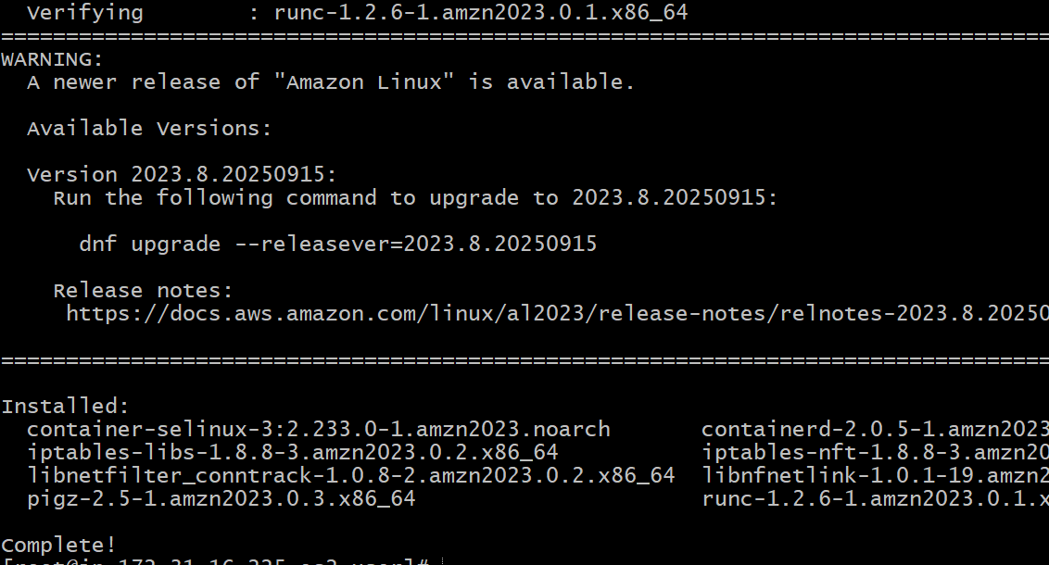

Sudo systemctl start docker

Sudo systemctl enable docker

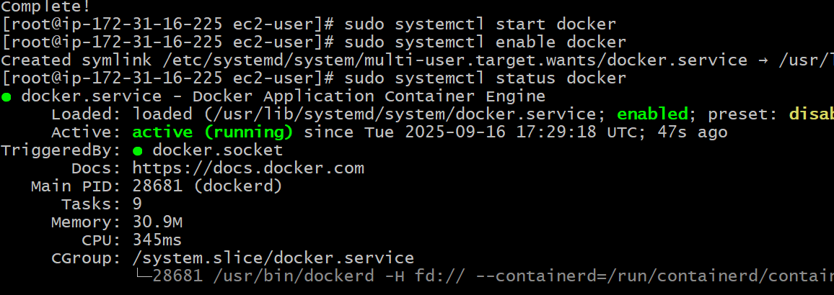

We can find the version by using docker --version

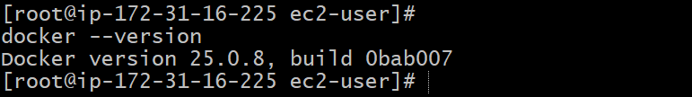

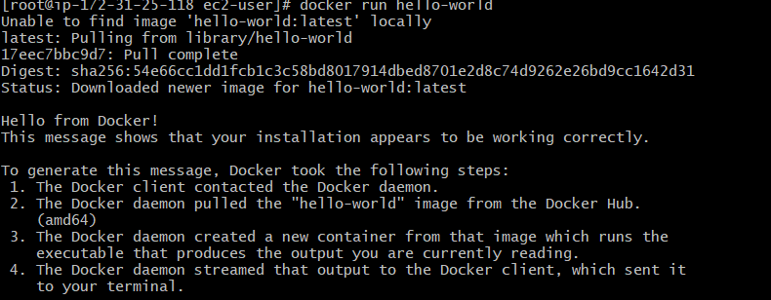

2.Install **Jenkins**

sudo yum update –y

sudo yum install java-21-amazon-corretto -y

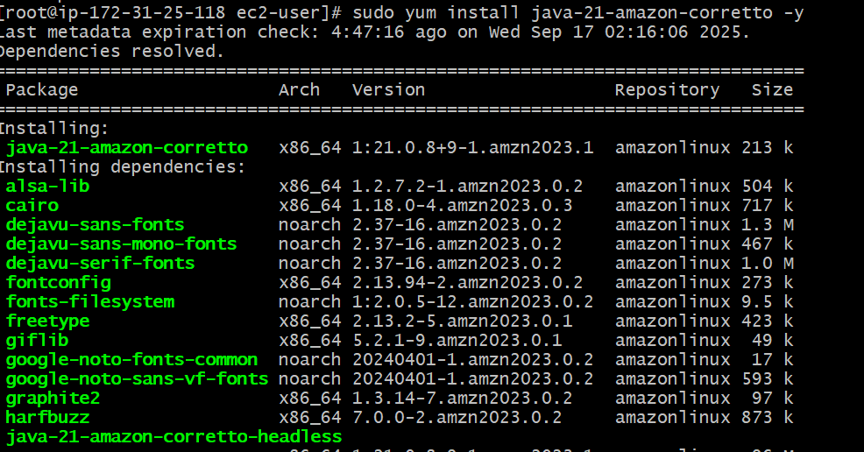

sudo yum install jenkins -y

sudo systemctl enable jenkins

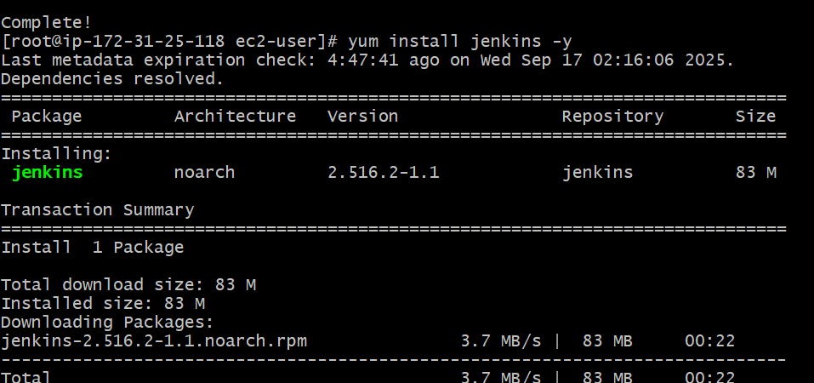

sudo systemctl start jenkins

sudo systemctl status jenkins

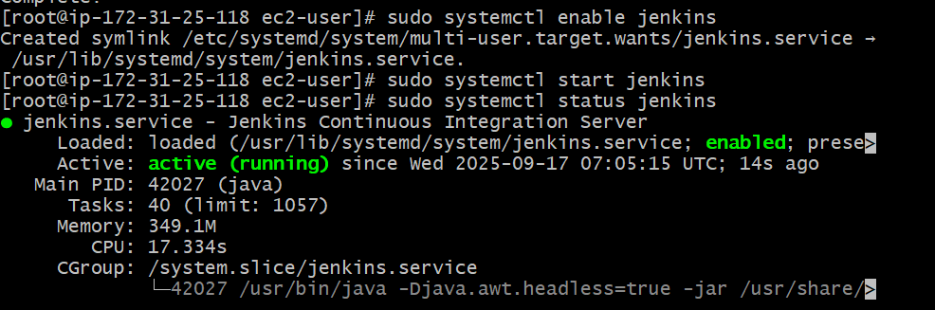

Jenkins runs on port 8080 by default. Access Jenkins through your web browser by entering http://your_server_ip:8080. You should see a screen asking for an initial administrator password

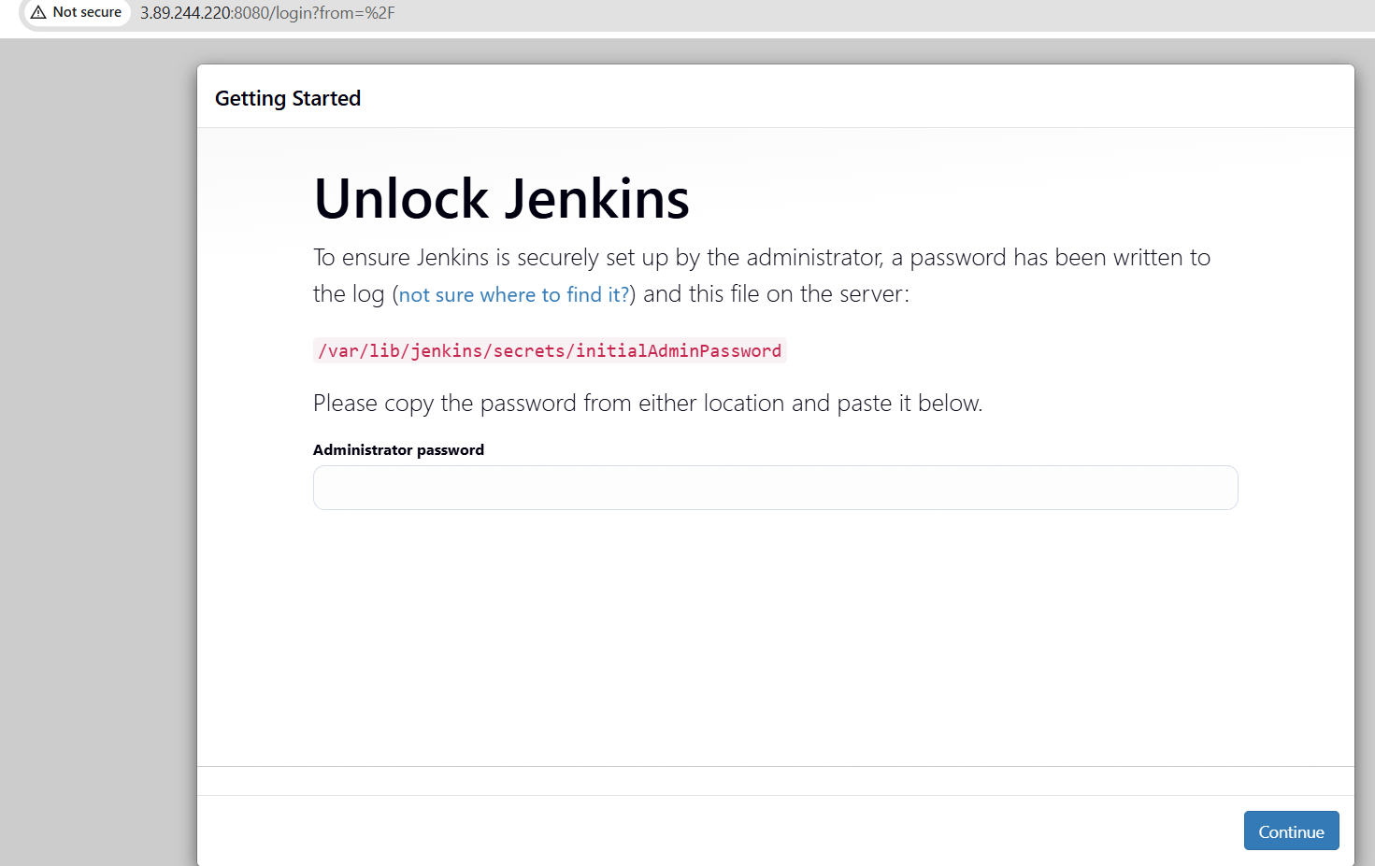



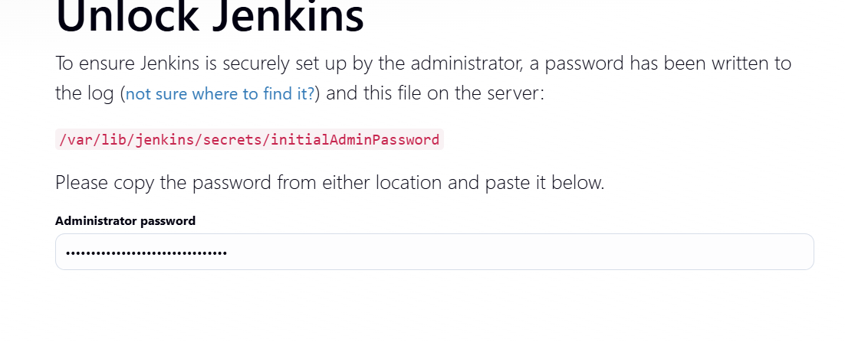

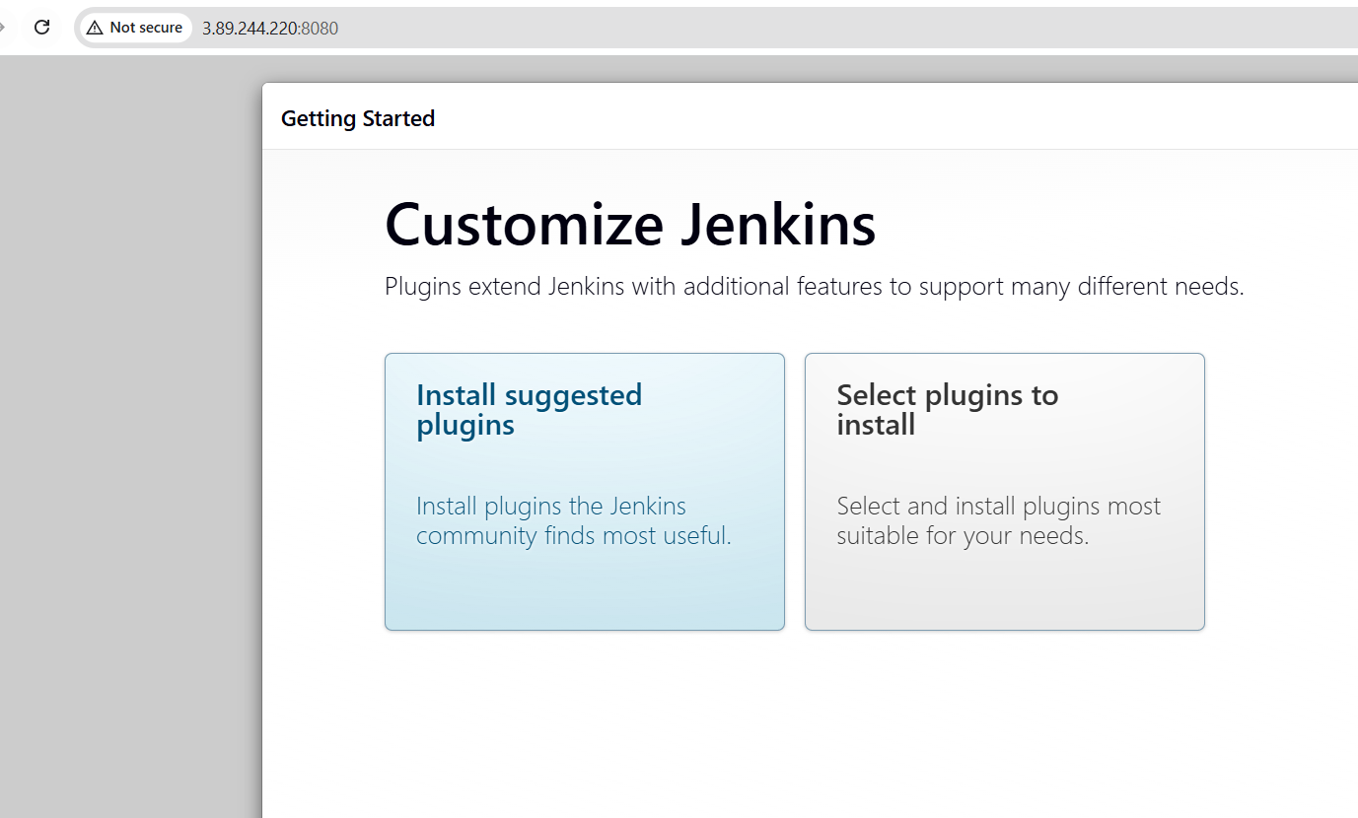

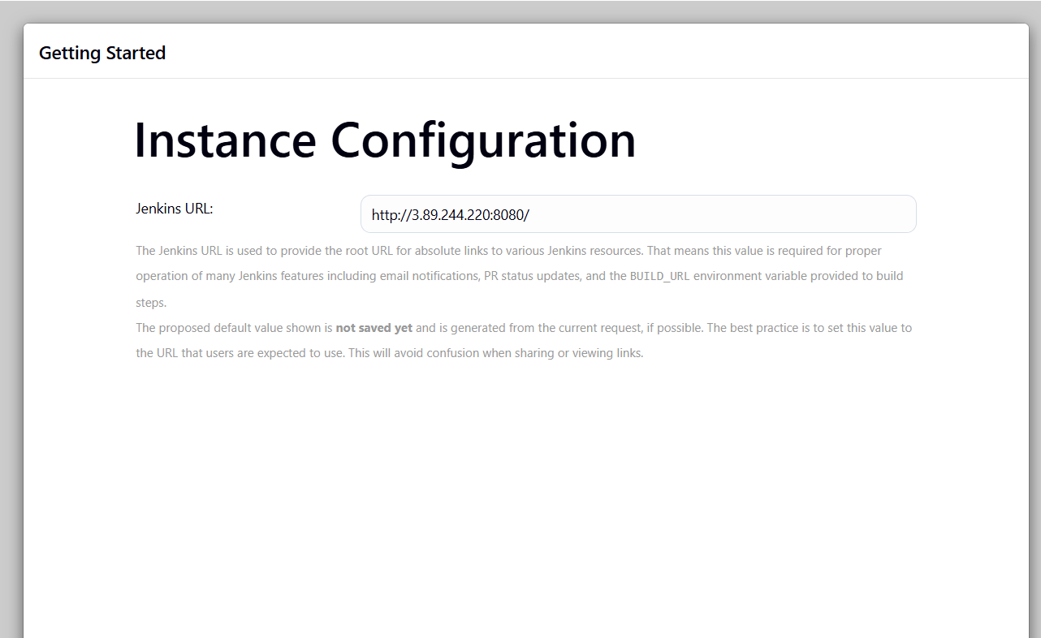

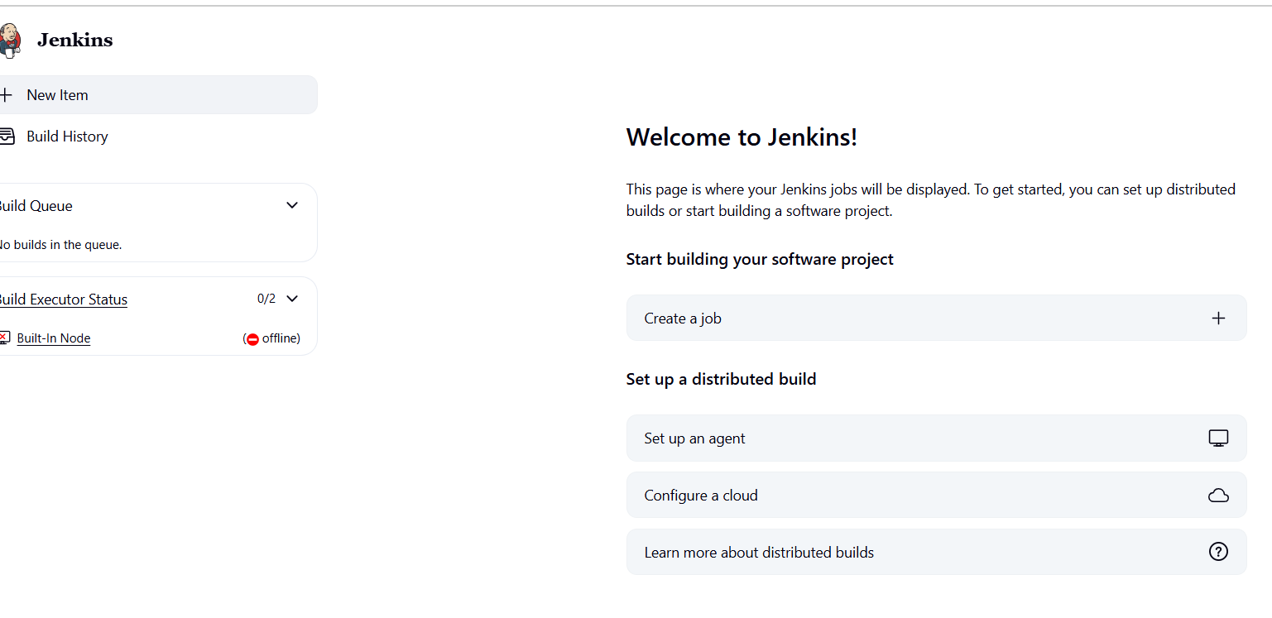

3. Install **Apache**

Yum install httpd

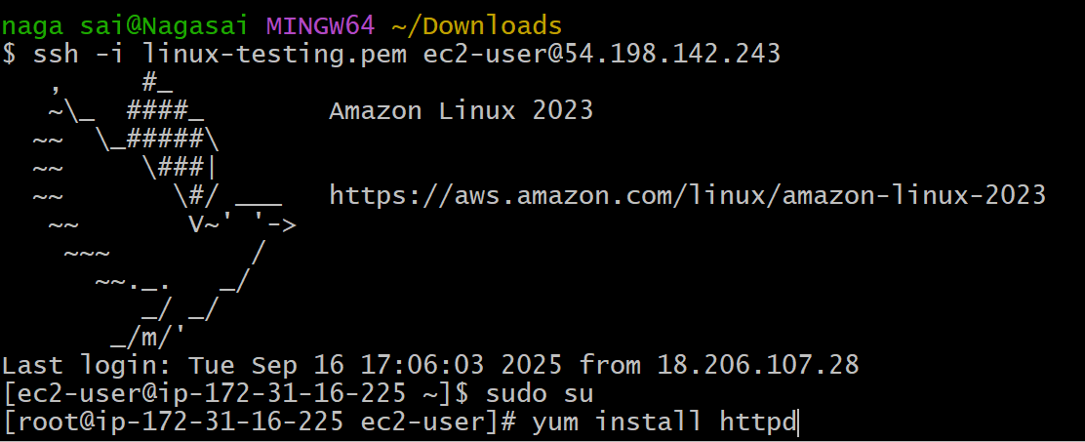

Sudo Yum install -y httpd

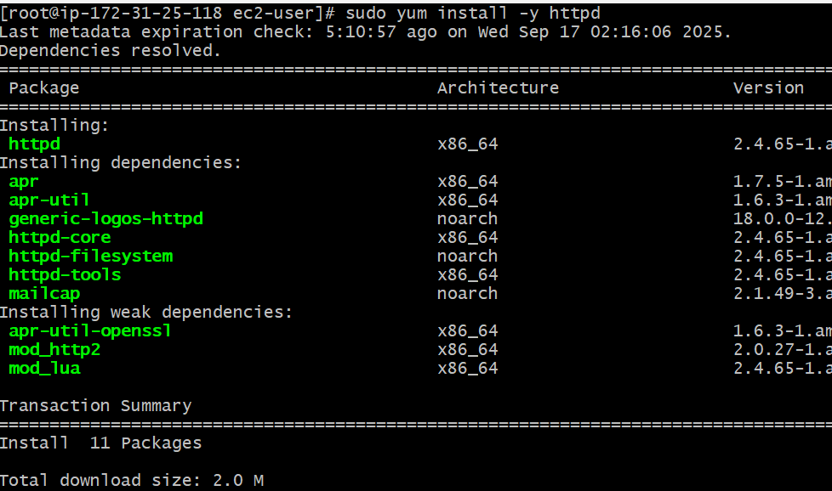

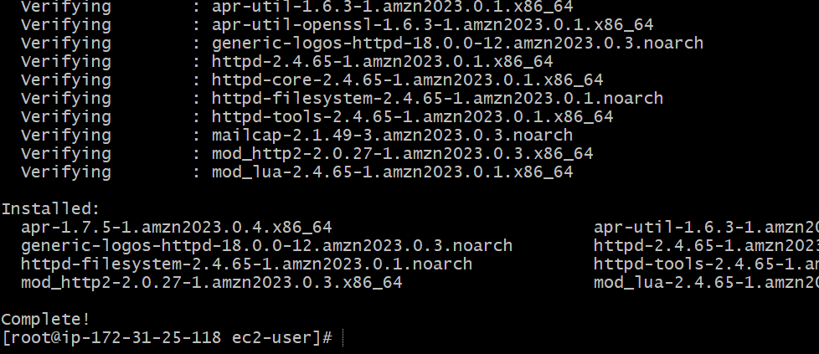

Sudo systemctl start httpd

Sudo systemctl status httpd

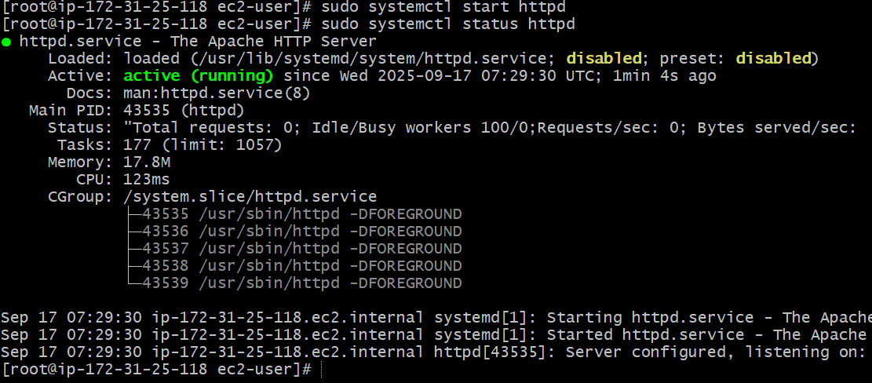

By default it works on port number 80.

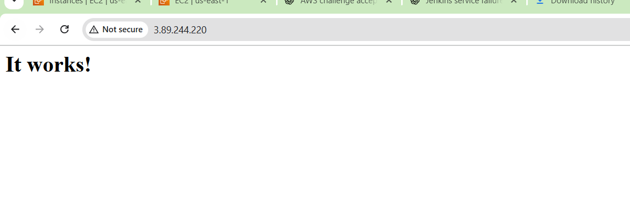

If we change to port number go to conf folder and edit the port number.

Sudo systemctl restart httpd

Sudo systemctl status httpd

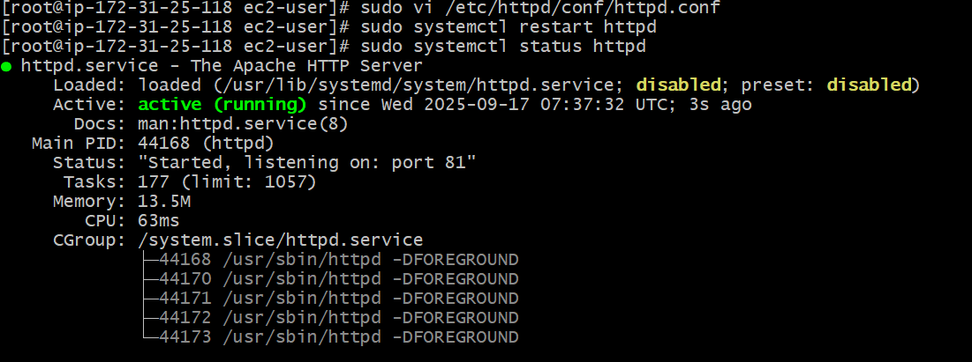

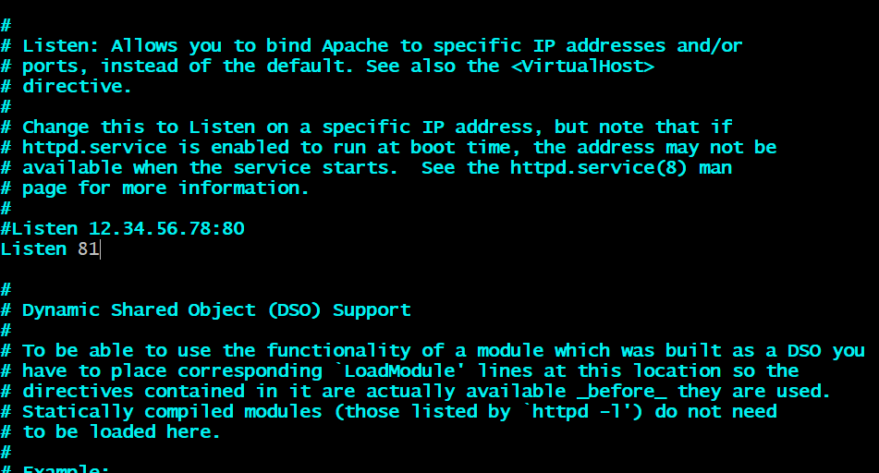

It works on port number 81.

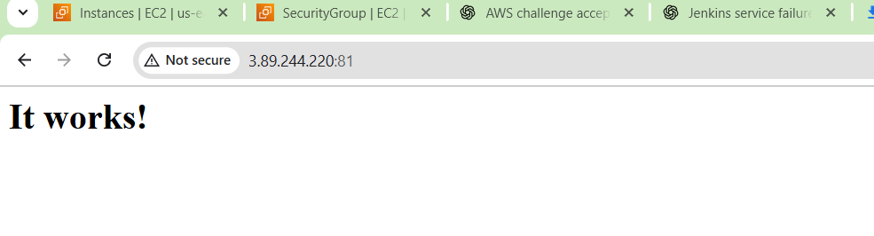

4.Install **Nginx**

Yum update -y

Sudo yum install -y nginx

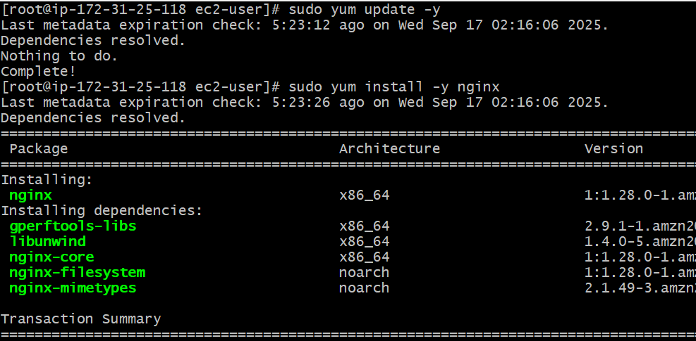

Sudo systemctl start nginx

Sudo systemctl status nginx

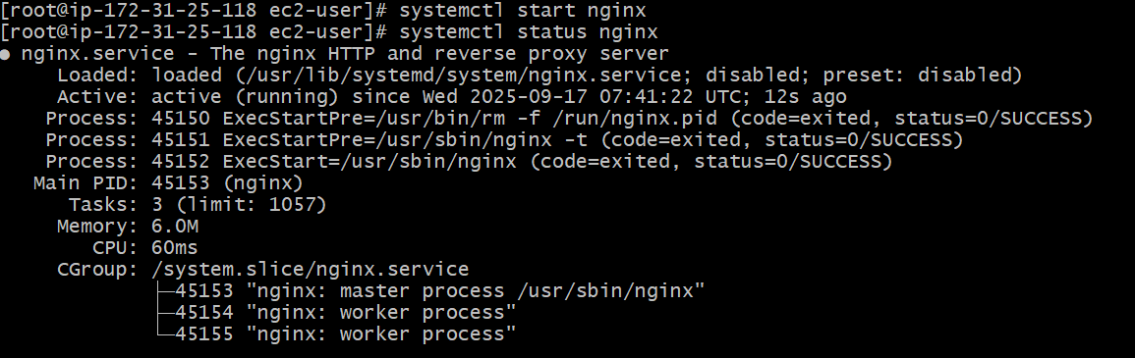

By default it runs on port no80

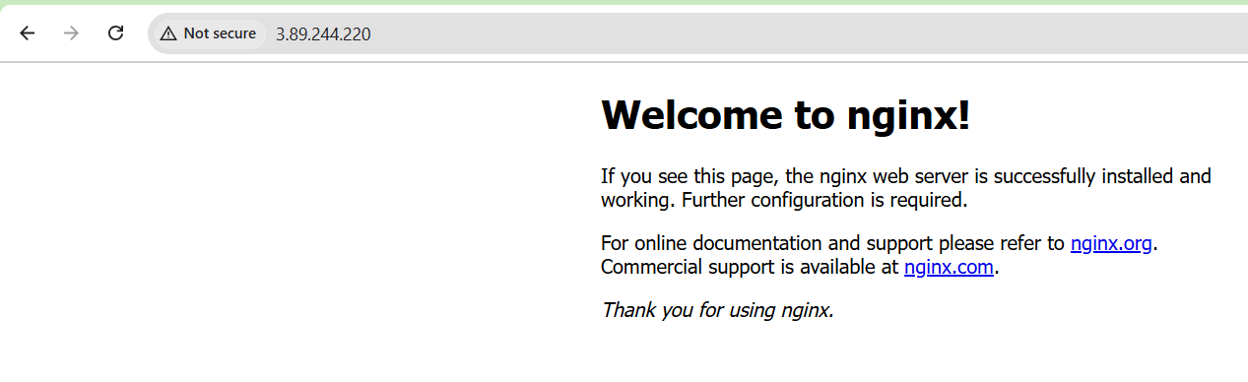

If we change to port number go to conf file and edit the port number.

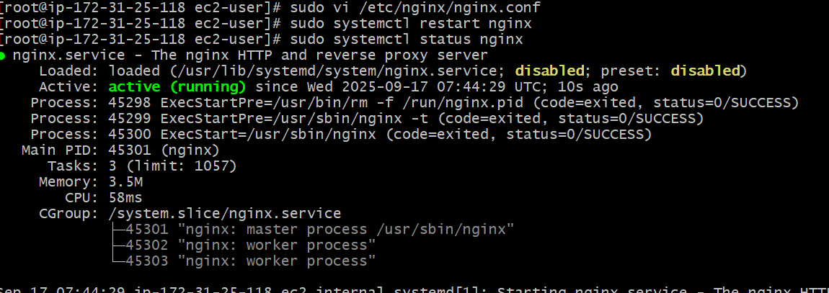

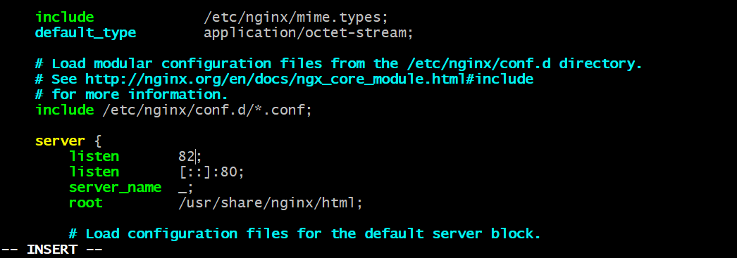

It works on port no 82.

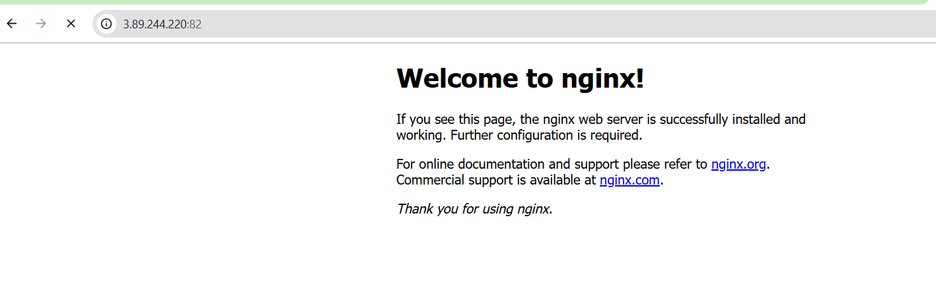

5. Install **Apache Tomcat**

Java –version

Go to google and find apache tomcat use wget to download and extract the file

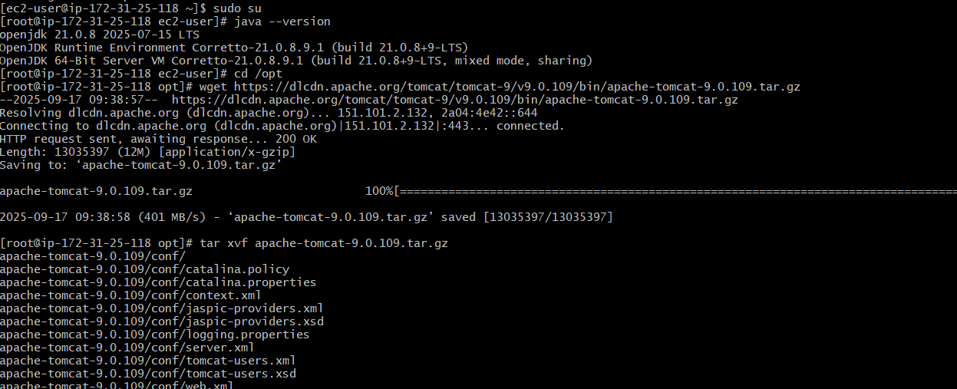

Rename the name by using mv.

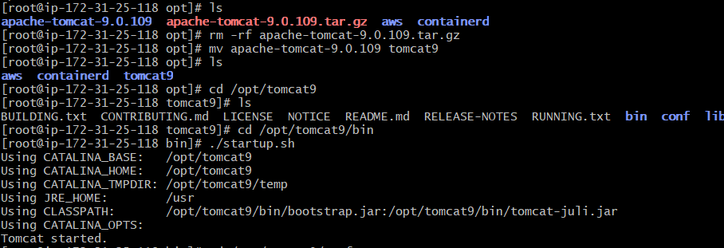

Go to conf and find server.xml .in server.xml we change the port number.

./startup.sh.

